

**CS4032 – Web Programming**

**Assignment No 1**

|  |  |
| --- | --- |
| **Instructor:** | Sumaira Mustafa |
| **Email:** | [sumaira.mustafa@nu.edu.pk](mailto:sumaira.mustafa@nu.edu.pk) |
| **Semester:** | Spring 2024 |
| **Section:** | BSCS-6C |

**Question 1: Personal Portfolio**

**Portfolio Link on Github:**

[**https://mozeb-ahmed-khan.github.io/Portfolio/**](https://mozeb-ahmed-khan.github.io/Portfolio/)

**Final Output:**

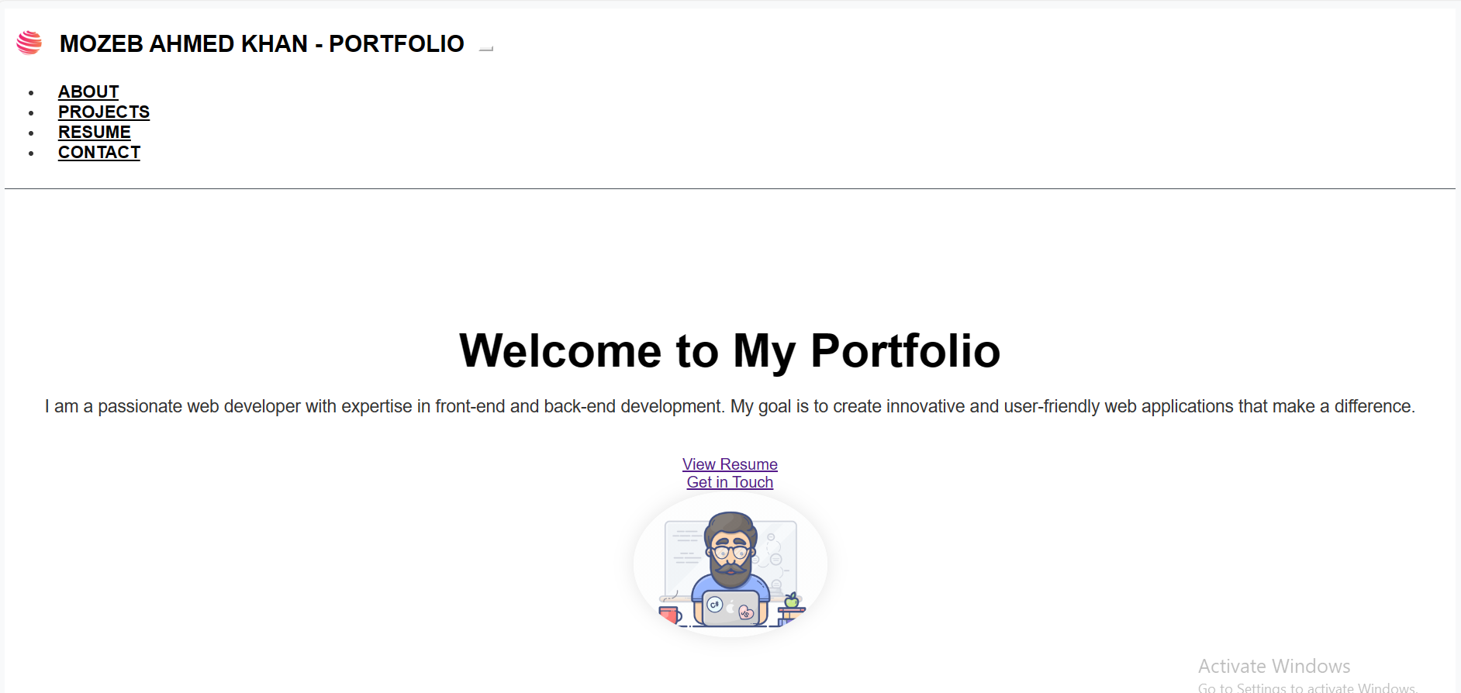

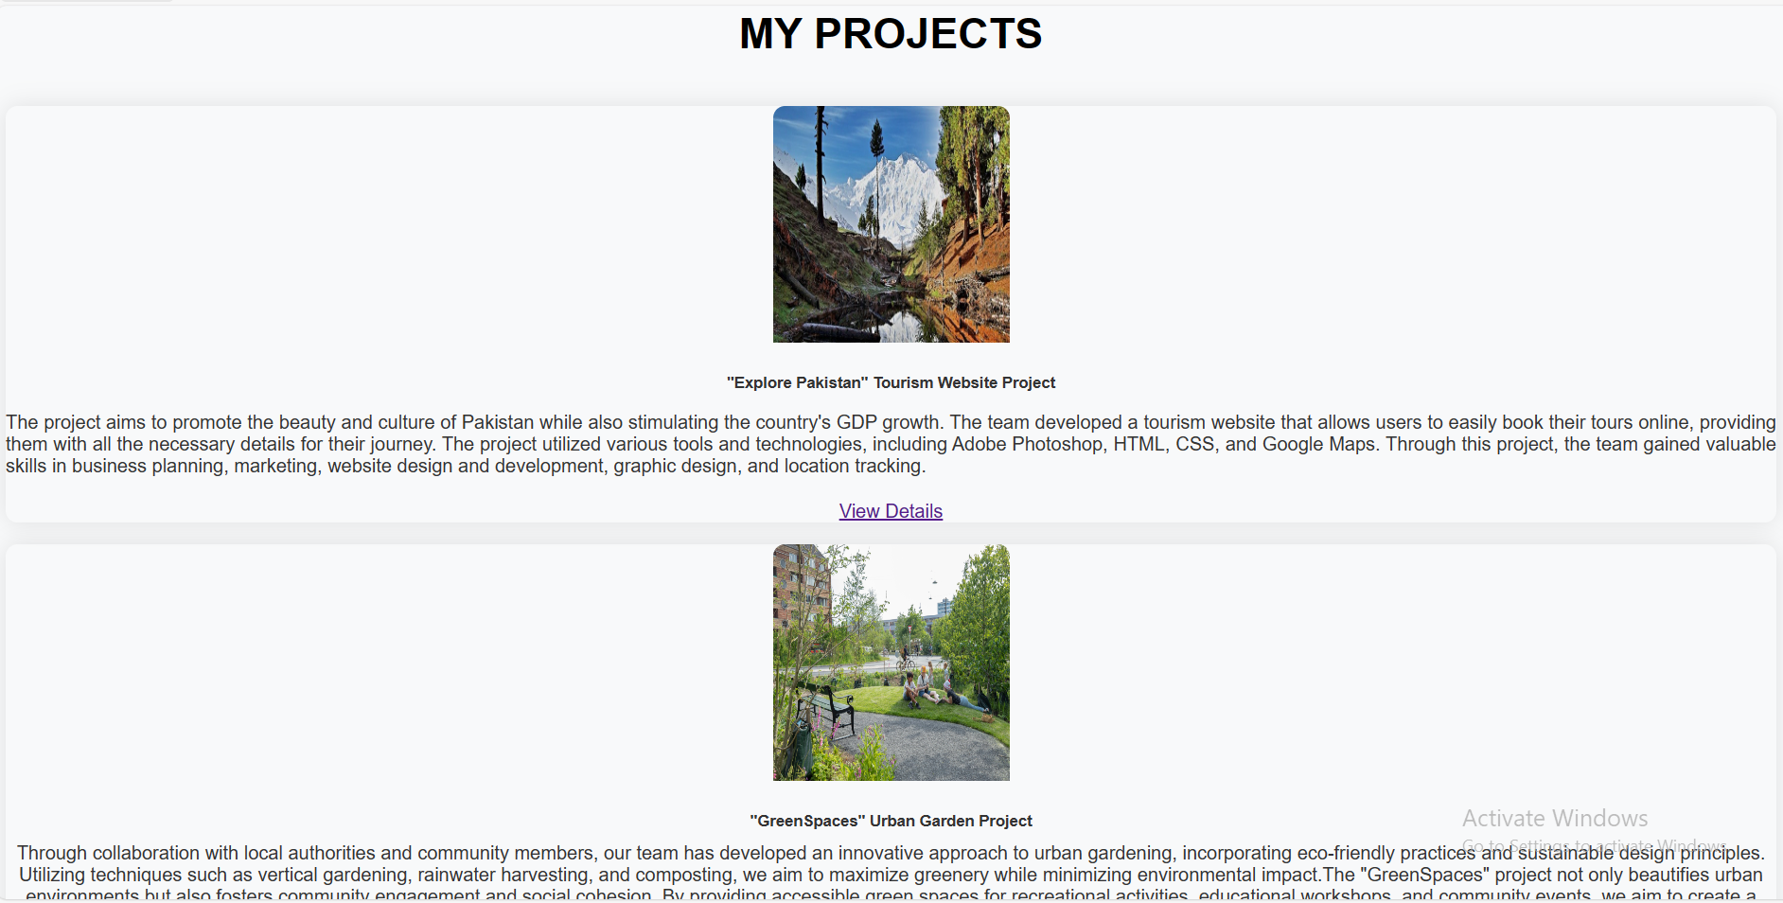

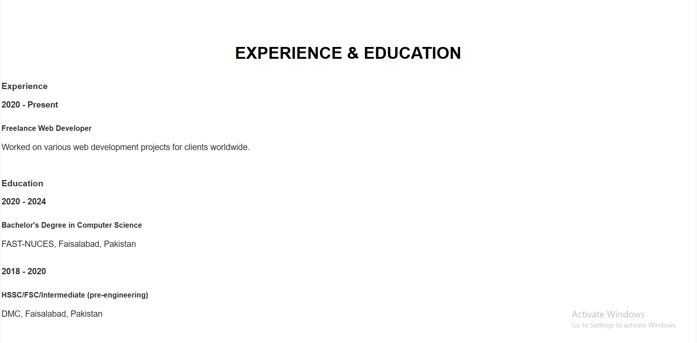

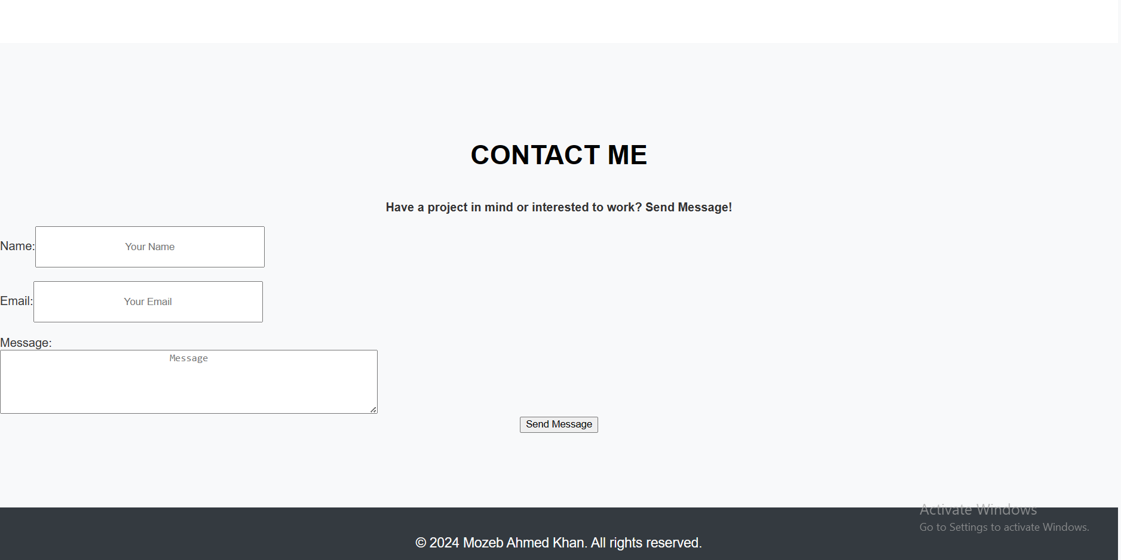

**Question 2: Weather App**

**Final Output:**

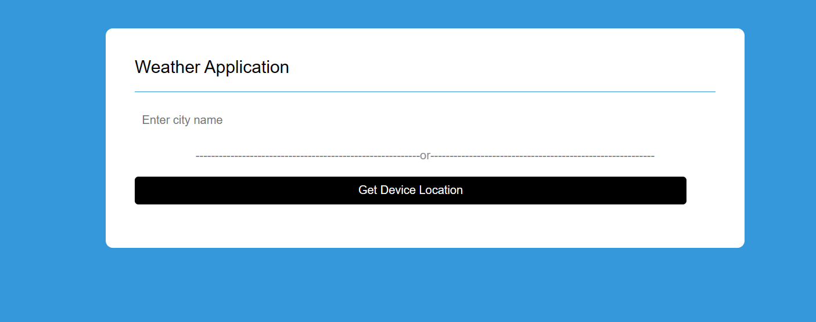

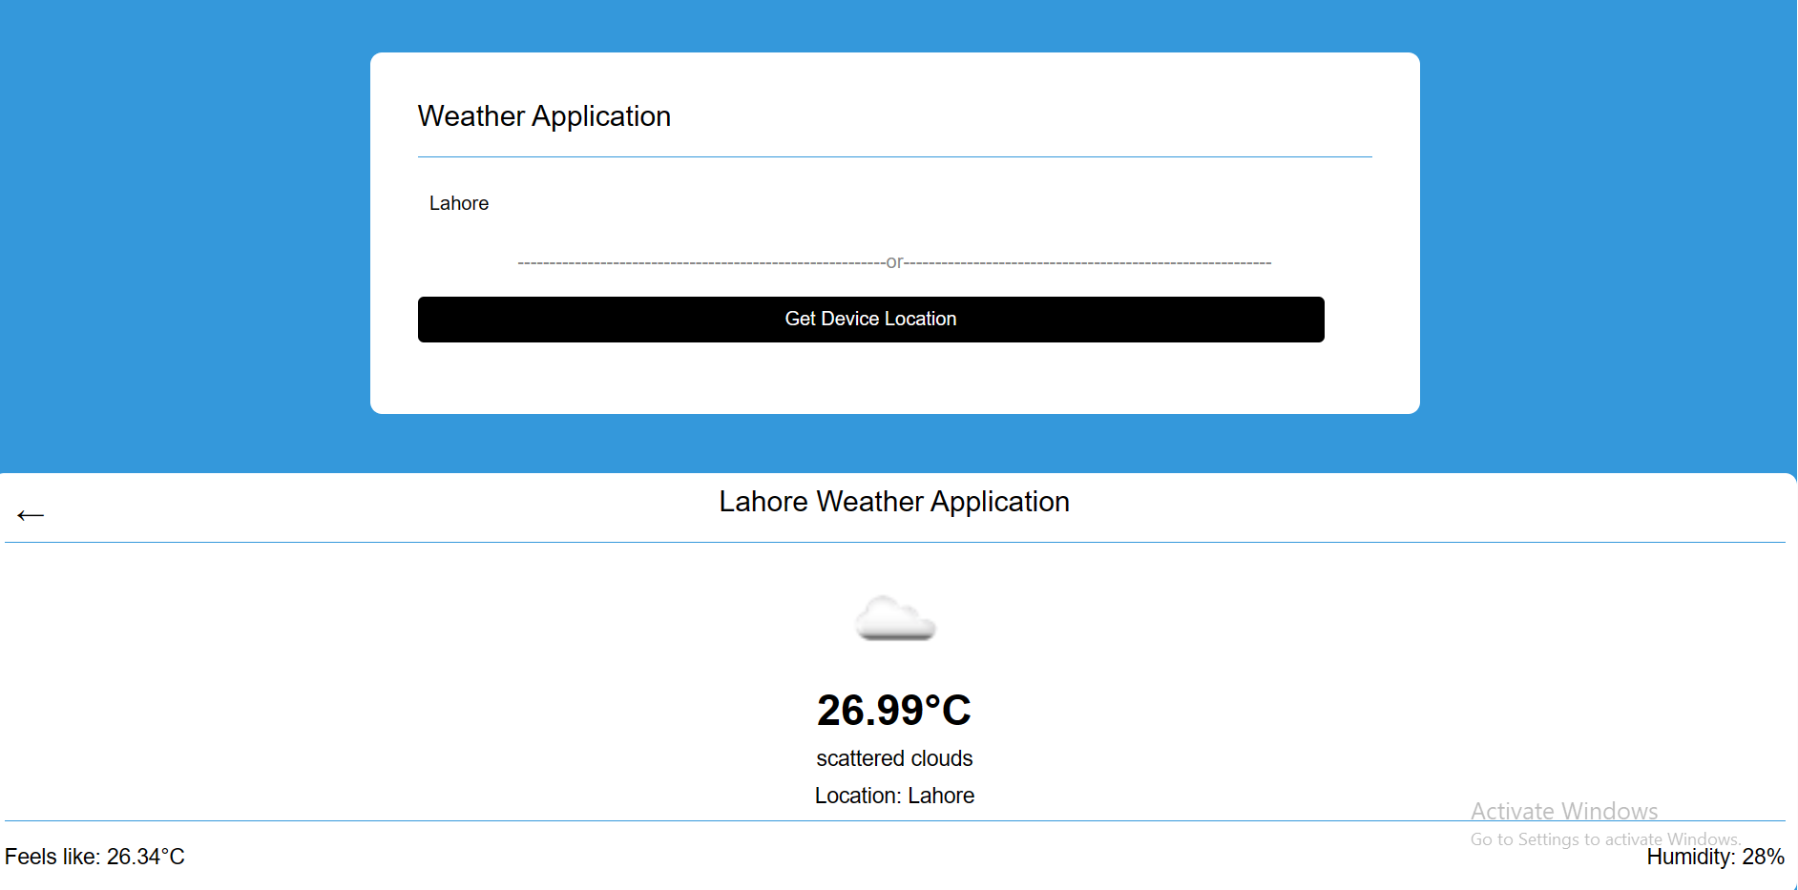

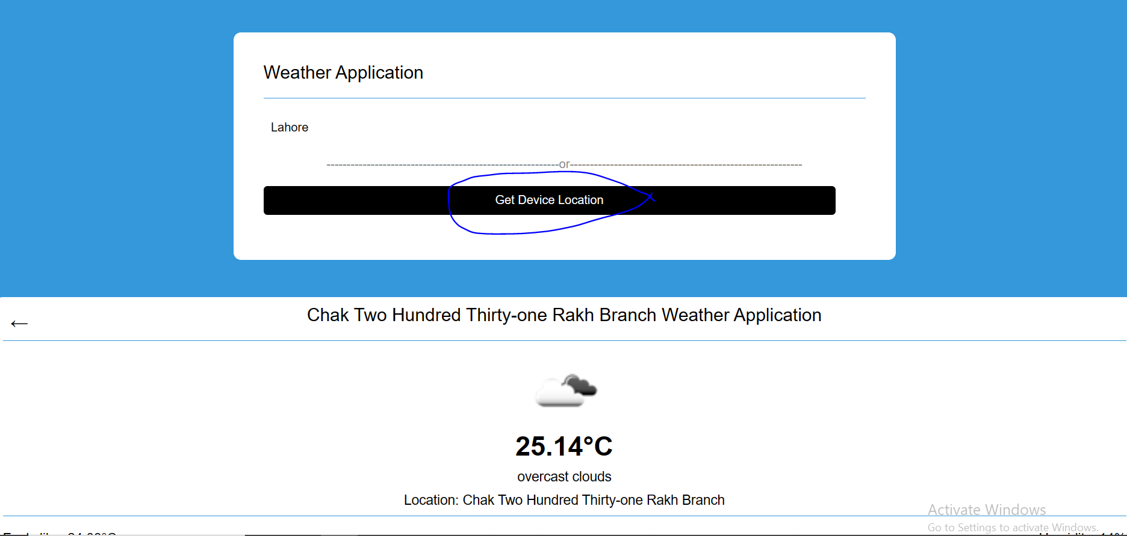

**Question 3: Personal Portfolio**

**Final Output:**

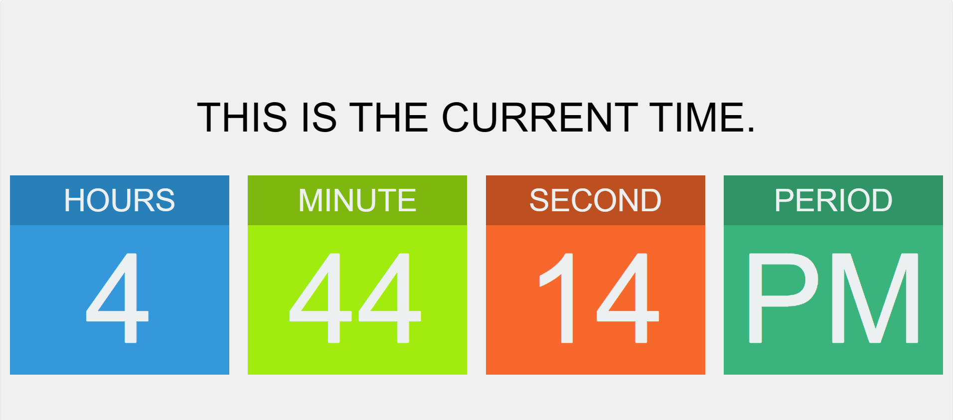

**Question 4: Rock Paper Scissor Game**

**Final Output:**

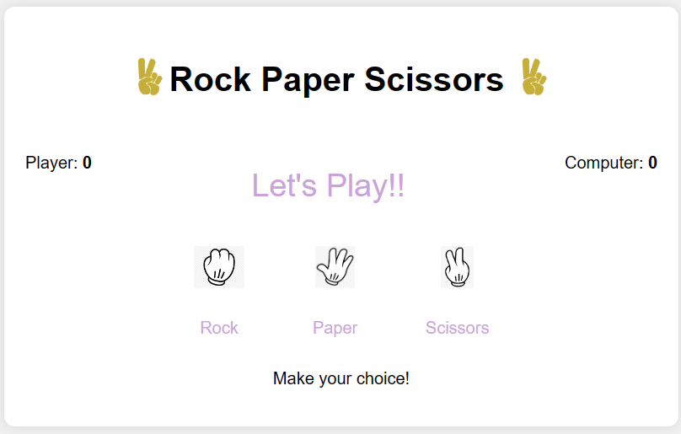

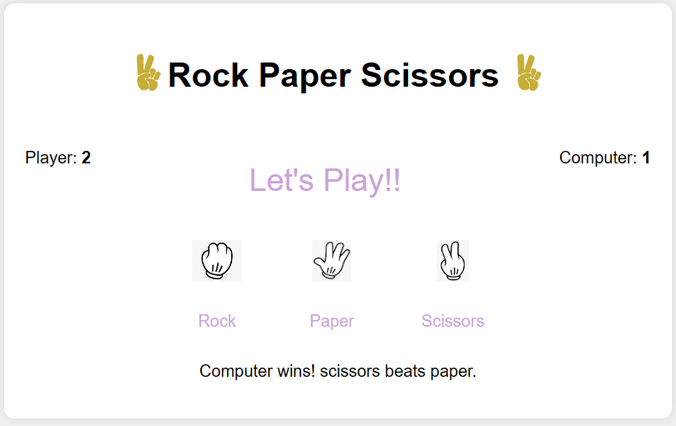

**Thank You**